Lab Practice:NumPy

- Create a 2D array with 1 on border and 0 on inside.
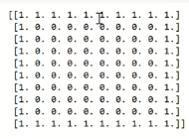
- Find indices of Non-zero elements from A[2,3,0,1,0,9].
- Create a zero one D vector of size 10 but 5th value should be 9.
- Create a 3×3 NumPy array of all True.
- Create a 4×4 array and extract its first row and last column.
- Get the positions where elements of array a and b match.
- Sorting a NumPy array based on a specific column.
Ex: Array = np.array([[34, 43, 73], [82, 22, 12], [53, 94, 66]]
Note:(Sort records according 2nd column)
- 8.Replace all odd numbers in a NumPy array with -1.
-------------------------------------------------------------------------------

